( A Division Of Pistana Welfare Society )
PISTANA, KEYI PANYOR DIST
ARUNACHAL PRADESH
PH:8876888348
Govt.Recog. No.EDA/09/2006-07

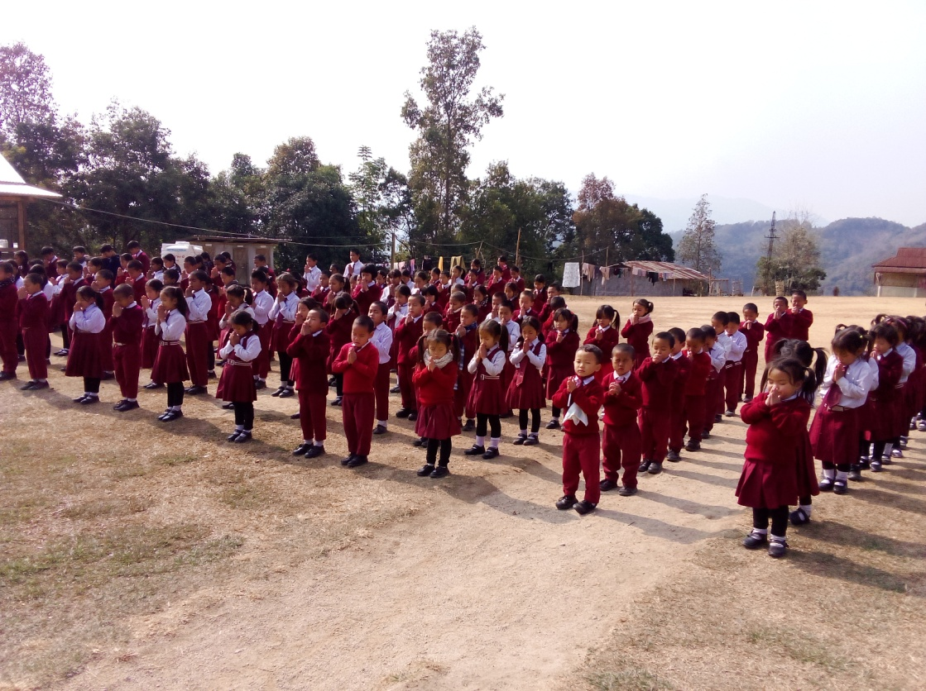

A CO-EDUCATIONAL INSTITUTION



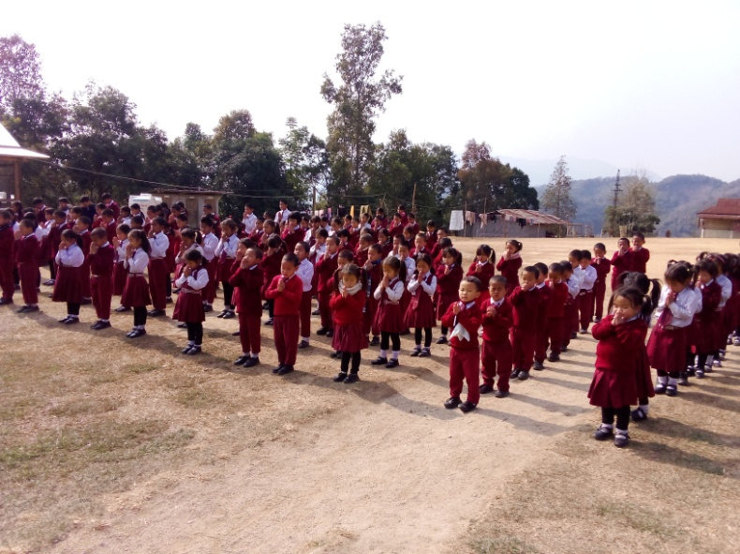

CLASSES FROM LKG - VIII
INTRODUCTION

Green Land Academy, is an English medium co-educational institution located at Pistana, the Headquarter of the Pistana circle, Keyi Panyor District, Arunachal Pradesh. It is run by Pistana Welfare Society. The institute started in the year 2002 with an aim to provide quality education to the children of Pistana circle in particular and the state as a whole. The institute opens classes from L.K.G to class VIII. The medium of instruction is strictly in English for all subjects except Hindi. The NCERT curriculum framework is followed. Constant effort of well trained and dedicated staff is to develop the individual personality of each pupil and bring out the qualities which are best novelist in them. Curricular and extra-curricular activities are the best in motivating the children.

GENERAL RULES & REGULATION
- GREEN LAND ACADEMY students are to be humble, obedient, punctual, regular and in and out of the school.
- No act of indiscipline, in-subordination, interference in the administration. Irrespective to any teachers or staff or religion or community by students shall not be tolerated and those found guilty may be expelled from the school/hostel.
- No student will be allowed to attend the class without proper uniform.
- Only English language is entertained in the school premises.
- No student will be allowed to go out of the school /hostel without the permission from the Principal.
- Smoking, drinking alcohol, chewing pan/tobacco items are strictly prohibited.
- If any student subsequently found it be liable to punish to extent of the expulsion from both school and hostel.
- Using of mobile phones strictly prohibited.
- Parents/guardians are required to extend their co-operation in all respect in moulding the character of their wards.
- Public holidays, restricted holidays or local holidays will be treated as holidays and the hosteller will not be allowed to go to resident until their leaves in the end of academic session/ on allotted holidays.
- Any damage caused to the school/hostel property by the student will be required to pay the cost of the lost or damage.
- Study hours will be strictly maintained by the boarders both in the morning and evening.
- No food items are allowed from out side to the hostel without permission.
- Use own things only. Do not use other’s things.
- No alteration work on dress/colouring of hair/tattooing/use of any kind of hair fixtures.
- Things brought to the students is directly through the office only.
- No valuable articles are allowed.

AIMS AND OBJECTIVES
- To impart intellectual, emotional and social growth of students.
- The institute will provide sound quality education leading to an atmosphere conclusive to build up good character responsible citizens based on mutual acknowledgement and quality.
- The institute will provide fine arts, handicrafts and vocational skills with a view to install in the students and spirit of self help and inculcate in them in the dignity of manual labour.

ADMISSION TO SCHOOL

A child must complete 4 years to get admission in LKG/UKG. The admission should be accompanied by the following documents:-
- Birth Certificate (in original)
- Aadhar card
- P.R.C (Original)
- ST Certificate.
- Copies of All vaccination Certificates from Govt.hospitals
All other classes
- T.C (original)
- Mark List
- P.R.C
- Aadhar Card.
- PEN with date of Birth.
- Copies of All vaccination Certificates from Govt.hospitals.

Admission is purely based on admission test.

COURSE AND SYLLABUS
The school follows the course and the syllabus prescribed the Central Board of Secondary Education (CBSE) from class VI onwards.
All other classes the syllabus followed by the Private Publications which are being followed by other schools.
EXAMINATIONS
There will be two Main examinations and two Periodic examinations during the academic session . The students will have to secure 33% marks in all subjects to pass in the examinations. Class V and VIII will have to follow APSB Examinations.

ABSENCE AND LEAVE

Staying away from the school without leave is not tolerated except when the course is sudden illness or unforeseen circumstances. No leave of absence is sanctioned nor a pupil is allowed to go away from the school/ hostel during the school hours without a prior permission. Such reasons like birthday, excursion, picnic festivals , urgent business, study time for examination etc. is not considered sufficient reason for leave.

FEES STRUCTURE HOSTELLER
LKG/UKG

FEES FOR HOSTELLERS :35,000 p.a
- First Installment : Rs.15,000/-
(At the Time of Admission)
- Second Installment : Rs.10,000/-
( In the month of July )
- Third Installment : Rs.10,000/-
(In the Month of November)
CLASS I-V

FEES FOR HOSTELLERS 40,000 p.a
- First Installment : Rs.15,000/-
(At the Time of Admission)
- Second Installment : Rs.15,000/-
( In the month of July )
- Third Installment : Rs.10,000/-
(In the Month of November)
CLASS VI-VIII

FEES FOR HOSTELLERS :42,000 p.a
- First Installment : Rs.15,000/-
(At the Time of Admission)
- Second Installment : Rs.15,000/-
( In the month of July )
- Third Installment : Rs.12,000/-
(In the Month of November)
NB:- FEES ONCE PAID WILL NOT BE REFUNDABLE AT ANY
CIRCUMSTANCES. BOOKS AMOUNT IS NOT INCLUDED IN FEES.
FEE CONCESSION/ FREE EDUCATION

- Free education for Orphan (Death certificate of father & mother is required from concerned authority/ Village HGB)
- 20% discount for semi-orphans (Death certificate of Parent is required).
- Four children from same parent will be given fully free education to one of them. Books, Uniform, school fee, hostel fee, Tie, Belt, Socks are free for the same student.
- More than one student from same parent will get 10% discount for one student.
- The school fees and other dues are liable to revise at any time.
- Student with dues will not be allowed to continue.
- The fees covers 12 months calendar. No fees reduction is made for holidays./broken periods.
- Parents/guardians should see that fees are paid at correct time given by the authority.
- No refund of annual/monthly fee for any reason(s) whatsoever.
CLASS TIMING
- 8:30am to 1:00pm
- Sunday Holiday
- Second Saturday Holiday
OFFICE TIME:7:00am – 4:00pm

VACATION

- Durga Puja holidays : 17th October to 24th October
- Winter Break :19th December to 9th January

UNIFORMS
FOR BOYS:-
- White full Sleeve shirt ````: 01 piece
- Maroon colour long pants : 01piece
- Tie : provided from school .
- Belt : provided from the school
- School shoes : 01 pair black colour.
- Plain white socks : 03 pairs
- Maroon school sweater : 01 piece
FOR GIRLS:-
- White full sleeve shirt : 01 piece
- Maroon colour Skirt : 01 piece
- Black colour leggings : 02 pairs
- Tie : provided from school
- Belt : provided from the school
- School shoes(girls) : 01 pair black colour
- Plain white socks : 03 pairs
- Maroon school sweater : 01 piece
- Hair rubber black in colour : 06 pairs.

THINGS BROUGHT TO THE HOSTEL FOR ONE YEAR

- Mattress : 01 nos
- Bed sheet : 02 nos
- Pillow : 01 nos
- Pillow cover : 02 nos
- Mosquito net : 01 nos
- Blanket(washable type) : as required
- White socks : 04 pairs
- Black shoes : 02pairs
- Neck tie : 01 nos
- School long pants : 01 nos
- School skirt (Girls) : 01 nos
- School sweater : 01 nos
- School shirt (long sleeve : 01 nos
- Under wear : 04 nos
- Slippers : 02 nos
- Civil shoes : 01 nos
- Civil socks : 06pairs
- Jackets : 02 pieces
- School bag : 01 nos
- Note books : only 180 and above pages
- Text books : provided from school on cost
- Geometry box (I to VIII : 01 nos
- Blue pen (V to VIII) : as required
- Trunk : 01 nos
- Lock & key : 01nos
- Hair oil : 10 Nos
- Shampoo : 10 bottles
- Bathing soap : 20 nos
- Washing soap/surf : 5kg (50 packets)
- Washing brush : 01
- Comb : 01
- Hair rubber black : 06 pairs
- Nail cutter : 01
- Vaseline/body lotion : as required
- Bath towel : 01
- Civil dress : 03 nos
- Bathing brush : 01
- Colgate : 15 nos (100gm X 15)
- Tooth brush : 03 nos
- Umbrella : 01 nos
PARENTS VISITING HOURS

Visitors other than parents/ concerned guardians are not allowed to visit any of the wards.
SUNDAY is a holiday and no visiting is allowed.
Parents can visit child with prior permission from the Principal and the visiting is allowed in the office only not in any of the premise.

FOOD & DINE

Hostellers are providing three times food as in the morning, afternoon and at night. No food items from outside is allowed in the hostel/dinning..

NB:- Plastics or Plastic covers are restricted.

